RESUME OF
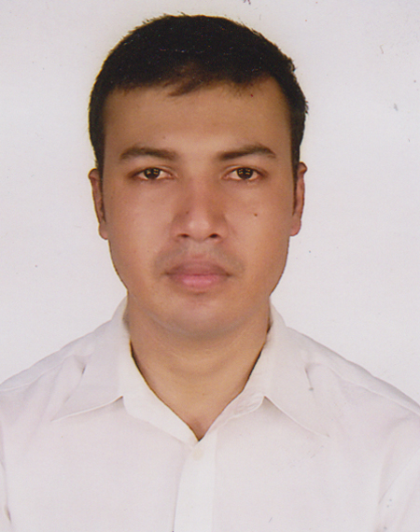

MD.ALI HAIDER MUNNA KHAN
House #3, Road #7, Khadim Nagar
Sylhet
Contact Phone : 01737-585566
E-mail: haiderkhan.munna@gmail.com
OBJECTIVE

To make a successful career through hard working, determination, dedication and serve the organization I will work in.
WORKING EXPERIENCE
- 15 months (01/8/2016 to present) working experience as Head of IE at Anowara group ( Narayangonj zone) .
- 3.5 years (03/06/2013 to 20/07/2016) working experience as a Manager (IE) at JM Fabrics Ltd. Gazipur .
- 4 years (7/06/2009 to 25/05/2013) working experience as a Manager (IE & Buyer relationship) at Arabi Fashion Ltd. Gazipur.
- 10 months (4/08/2008 to 31/5/2009) Working experience as an Industrial Engineer at Fakruddin Textile Mills Ltd. Gazipur .
JOB RESPONSIBILITIES

- I do follow up entire IE activities of our company (Narayangonj zone) .
- I am responsible for improving production & productivity .all the IE practice (like , capacity study ,production study , time study ,line feeding ,quick change over etc ) is done by IE team under my supervision .
- Do follow up supply chain (Cutting to finishing) & regularly keep in touch with planning team to make planning fully functional.
- We do follow up extra OT hour schedule & try to reduce as much as possible.
- All CM offering is given by me to the buyer desk .
- I do make KPI report of RMG section (monthly, half yearly & yearly) for Director sir & MD Sir , so that they can figure out where we are & where we need to be .
ACADEMIC BACKGROUND

- B.Sc. (Engr.) In Industrial & Production Engineering, 2008
Shah Jalal University of Science & Technology (SUST), Sylhet
Obtain Grade: B-
- Higher Secondary Certificate Examination (H.S.C), 2002
Jalalabad Cantonment Public School & College,Sylhet.
Science group, Sylhet Board, First division.
- Secondary School Certificate Examination (S.S.C), 2000
Golam Mostofa Chowdhury Academy,Zakigonj .
Science group. Comilla Board, First division.

MAJOR SUBJECT IN B.SC. ENGINEERING

Production planning & control, Industrial Management ,Project Management ,Total Quality Management ,Management Information System ,Logistic & supply Chain Management ,Technology Management & Entrepreneurship Development ,Engineering Economy ,Engineering Statistics ,Automated Manufacturing System, Operation Research, Engineering mechanics, Machine Tool, Industrial Simulation, Industrial Law etc.
TRAINING EXPERIENCE

- Attended two weeks Industrial Training Bangladesh Blade Factory Ltd. Tongi.
- One day industrial tour to Chatak Cement Factory, Sylhet.
- Attended three weeks training on Industrial technology on mechanical engineering at TICI, Polash. Narshindi.
- 12 days training on Productivity Improvement Cell (PIC) conducted by BKMEA .
PROJECT

- Design & development of a multi usable hanger.
- Design & development of an optical memory reader.
SEMINAR

- Safety in machine shop.
- Product design & development.
THESIS
Implementation of Quality Function Deployment in Product Development - An Exploratory Study with Alim Power
Tiller.
KEY COMPETENCY
- Confident to take challenge.
- Hard working .
- Self-driven & change oriented.
- High managing power .
- Strong communication skill .
COMPUTER SKILL
Application Software, MS office , MS excel .
LANGUAGE SKILL
Good command in both Bangla & English.

PERSONAL INFORMATION

Name : Md Ali Haider Munna Khan
Father's Name : Md Riaz Uddin Khan
Mother's Name : Afia Khatun Chowdhury
Date of Birth : June 24 ,1984
Present & Permanent Address : House #3, Road #7, Khadim Nagar . Sylhet.
Nationality : Bangladeshi
Marital status : Married
REFERENCES

Engr .Gopi Rajon Talukder
DGM(IE & Planning )
Asrotex Ltd .
Cell : 01712 82 70 48

